**Experiment 3**

**Student Name:** Sahil Kaundal **UID:** 21BCS8197

**Branch:** CSE (Lateral Entry)  **Section/Group:** 616/A

**Semester:** 6th **Date of Performance:** 02/03/2023

**Subject Name:** Data Mining Lab **Subject Code:** 20CSP-376

1. **Aim:**

Demonstration of association rule mining using Apriory algorithm on supermarket data.

1. **Apparatus / Simulation Used:**

* Windows 7 or above
* R Studio

1. **Objective:**

* Represent the reading of file using R Studio.
* Displaying the pattern on Weka Tool.
* Demonstration of association rule mining using Apriory algorithm.

1. **Script and Output:**

library(arules)

library(arulesViz)

library(RColorBrewer)

data("Groceries")

rules <- apriori(Groceries,

parameter=list(supp=0.01, conf=0.2))

inspect(rules[1:10])

arules::itemFrequencyPlot(Groceries, topN=20,

col=brewer.pal(8,'Pastel2'),

main='Relative Item Frequency Plot',

type = "relative",

ylab = " Item Frequency Relative")

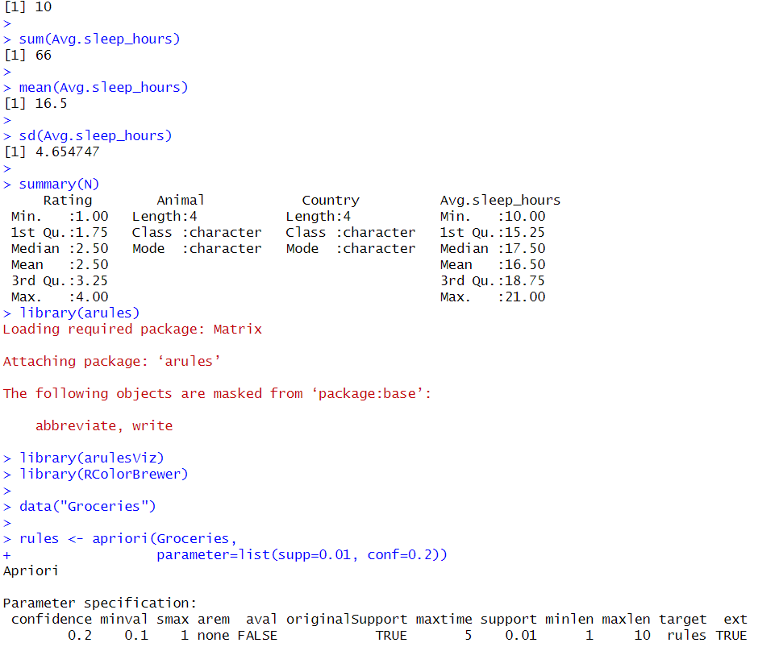

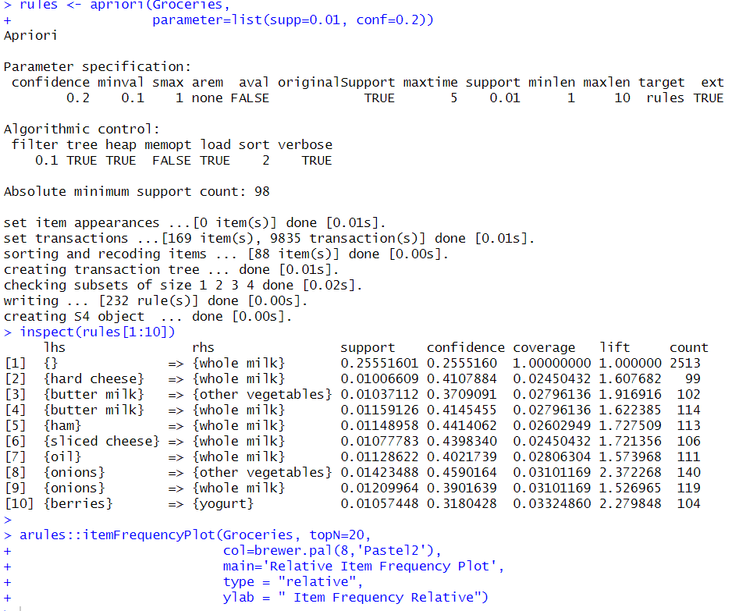

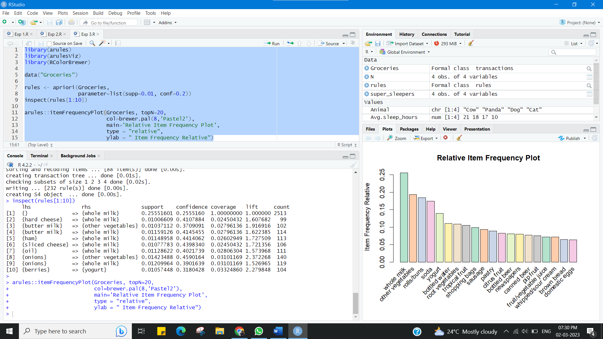

**Learning outcomes (What I have learnt):**

* Represent the reading of file using R Studio.
* Displaying the pattern on Weka Tool.
* Demonstration of association rule mining using Apriory algorithm.

**Evaluation Grid (To be created as per the SOP and Assessment guidelines by the faculty):**

|  |  |  |  |
| --- | --- | --- | --- |
| Sr. No. | Parameters | Marks Obtained | Maximum Marks |
| 1. |  |  |  |